**TASK 1**

**Objective:**

Compile following code and observe the result.

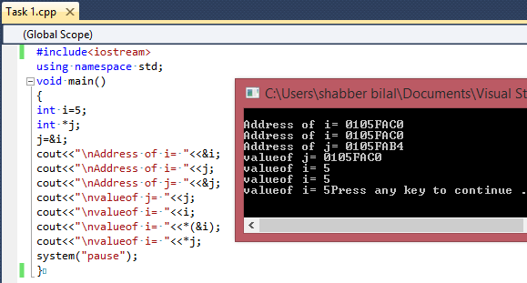

**TASK 2**

**Objective:**

Write a function that calculates the square of any integer given by user. Pass the value by reference.

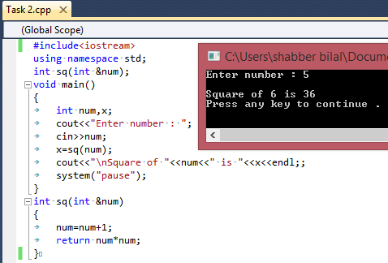

**TASK 3**

**Objective:**

Write a function that calculates the area of circle. Pass the parameter by reference.

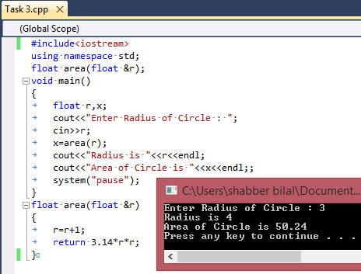

**TASK 4**

**Objective:**

Write a function that swaps the values of two integers by using pointers.

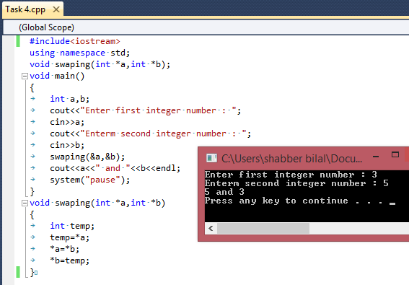

**TASK 5a**

**Objective:**

Write a program that contains array of type character. Elements of array should be from A to J. Print this array with help of pointers. Also prints the addresses of array elements.

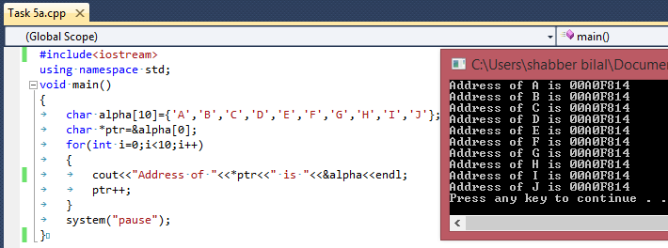

**TASK 5b**

**Objective:**

Print array elements in reverse order.

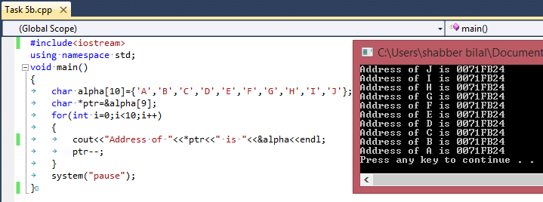

**TASK 6**

**Objective:**

Write a program that contains array of type integer. The length of array should be 10.Calculate the sum, average of elements of array using pointer.

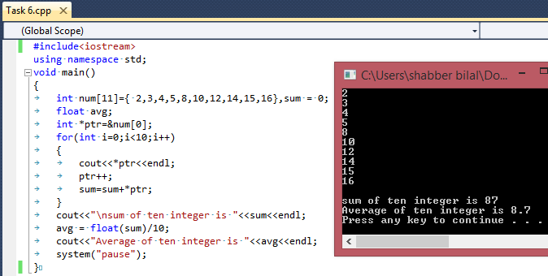

**TASK 7**

**Objective:**

Write a program that contains array of 10 integer elements. Calculate the square and cube of all element using pointers.

